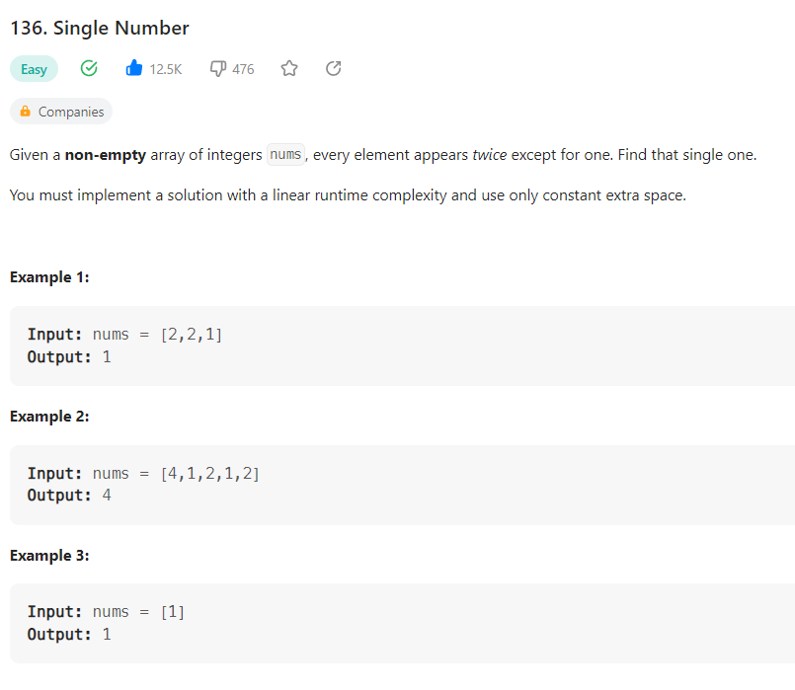

**Solution 1:**

**# n = n ^ 0 🡪 1^1 = 0, 0^0 = 0, 1^0 = 1, 0^1 = 1**

class Solution:

    def singleNumber(self, nums: List[int]) -> int:

    def singleNumber(self, nums):

        num = 0

        for n in nums:

            num = n ^ num

        return num

run = Solution()

run.singleNumber([4,1,2,1,2])

**Output:**

4

**Time Complexity:** O(n)

**Space Complexity:** O(n)